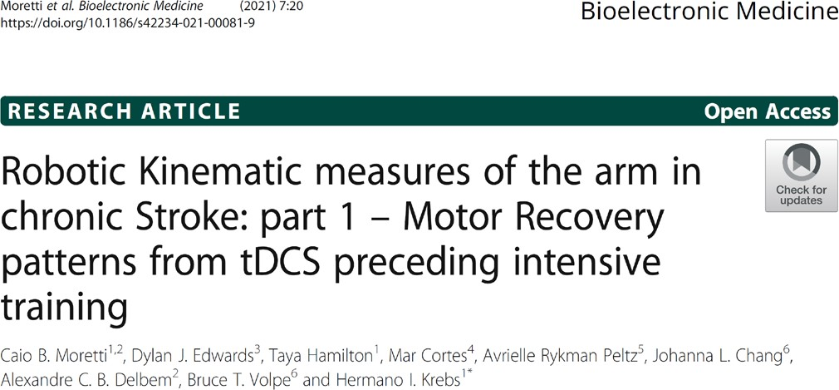SPECIAL INTEREST GROUP:

ROBOTICS

Notes from SIG-Robotics January 2022

Abstract
Background: Effectiveness of robotic therapy and transcranial direct current stimulation is conventionally assessed with clinical measures. Robotic metrics may be more objective and sensitive for measuring the efficacy of interventions on stroke survivor’s motor recovery. This study investigated if robotic metrics detect a difference in outcomes, not seen in clinical measures, in a study of transcranial direct current stimulation (tDCS) preceding robotic therapy. Impact of impairment severity on intervention response was also analyzed to explore optimization of outcomes by targeting patient sub-groups.
Methods: This 2020 study analyzed data from a double-blind, sham-controlled, randomized multi-center trial conducted from 2012-2016, including a six-month follow-up. 82 volunteers with single chronic ischemic stroke and right hemiparesis received anodal tDCS or sham stimulation, prior to robotic therapy. Robotic therapy involved 1024 repetitions, alternating shoulder-elbow and wrist robots, for a total of 36 sessions. Shoulder-elbow and wrist kinematic and kinetic metrics were collected at admission, discharge, and follow-up.
Results: No difference was detected between the tDCS or sham stimulation groups in the analysis of robotic shoulder-elbow or wrist metrics. Significant improvements in all metrics were found for the combined group analysis. Novel wrist data showed smoothness significantly improved (P < ·001) while submovement number trended down, overlap increased, and interpeak interval decreased. Post-hoc analysis showed only patients with severe impairment demonstrated a significant difference in kinematics, greater for patients receiving sham stimulation.
Conclusions: Robotic data confirmed results of clinical measures, showing intensive robotic therapy is beneficial, but no additional gain from tDCS. Patients with severe impairment did not benefit from the combined intervention. Wrist submovement characteristics showed a delayed pattern of motor recovery compared to the shoulder-elbow, relevant to intensive intervention-related recovery of upper extremity function in chronic stroke.
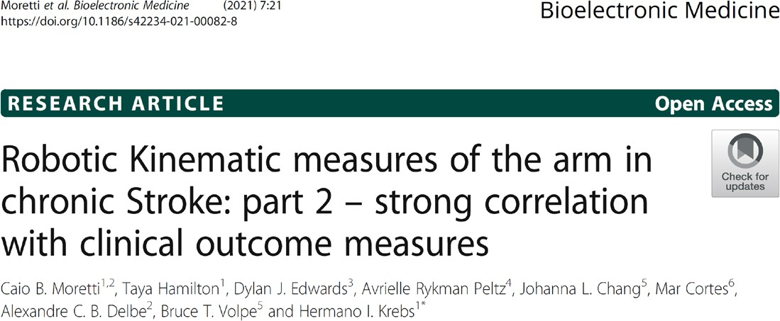

Abstract
Background: A detailed sensorimotor evaluation is essential in planning effective, individualized therapy post-stroke. Robotic kinematic assay may offer better accuracy and resolution to understand stroke recovery. Here we investigate the added value of distal wrist measurement to a proximal robotic kinematic assay to improve its correlation with clinical upper extremity measures in chronic stroke. Secondly, we compare linear and nonlinear regression models.
Methods: Data was sourced from a multicenter randomized controlled trial conducted from 2012-2016, investigating the combined effect of robotic therapy and transcranial direct current stimulation (tDCS). 24 kinematic metrics were derived from 4 shoulder-elbow tasks and 35 metrics from 3 wrist and forearm evaluation tasks. A correlation-based feature selection was performed, keeping only features substantially correlated with the target attribute (R > 0.5.) Nonlinear models took the form of a multilayer perceptron neural network: one hidden layer and one linear output.
Results: Shoulder-elbow metrics showed a significant correlation with the Fugl Meyer Assessment (upper extremity, FMA-UE), with a R=0.82 (P<0.001) for the linear model and R=0.88 (P<0.001) for the nonlinear model. Similarly, a high correlation was found for wrist kinematics and the FMA-UE (R=0.91 (P<0.001) and R=0.92 (P<0.001) for the linear and nonlinear model respectively). The combined analysis produced a correlation of R=0.91 (P<0.001) for the linear model and R=0.91 (P<0.001) for the nonlinear model.
Conclusions: Distal wrist kinematics were highly correlated to clinical outcomes, warranting future investigation to explore our nonlinear wrist model with acute or subacute stroke populations
Hermano Igo Krebs, Ph.D. MIT, The 77 Lab, Cambridge, MA, USA

We invite you to check the online lecture s es on rehabilitation robotics and eri neurostimulation. It took place August 2021 at Hospital Albert Einstein in Sao Paulo, Brazil. The lectures can be seen at:

https://academiadigital.einstein.br/oe/610/vide o

We invite you to participate in 13th Annual Meeting of the Japanese Society for Neural Repair and Neurorehabilitation. This conference will take place on 12 February 2022 in Kobe, Japan.

https://www.c-linkage.co.jp/neurorehab2022/

We invite you to participate in the upcoming IEEE-BioRob 2022 Conference in Seoul, South Korea. This engineering conference will take place on 21-24 August 2022.

http://biorob2022.org/

Dylan J.
Edwards, Ph.D.

Moss Rehabilitation Research Institute, Philadelphia, PA, USA

We invite you to participate in the upcoming “Robotics and Technology in Rehabilitation Symposium.” It will take place at the Moss Rehabilitation Hospital on April 29 and 30, 2022 (for more details see 2nd page).

We invite you to participate in the upcoming World Congress of WFNR in Vienna, Austria, 14-17 December 2022.

https://www.wfnr.co.uk/events/wfnr-world- congress-2022

NEW MEMBERS:
- Jose Lopez, clinical director at European Neurosciences Center in Madrid, Spain
- Michel Fataki Likale, MD, Belgium

PAPERS:

We recommend the reading of the following papers:

Edwards DJ, Cortes M, Rykman-Peltz A, Chang J, Elder J, Thickbroom G, Mariman JJ, Gerber LM, Oromendia C, Krebs HI, Fregni F, Volpe BT, Pascual-Leone A. Clinical improvement with intensive robot-assisted arm training in chronic stroke is unchanged by supplementary tDCS. Restor Neurol Neurosci. 37(2):167-180 (2019).

Agrafiotis DK, Yang E, Littman GS, Byttebier G, Dipietro L, DiBernardo A, Chavez JC, Rykman A, McArthur K, Hajjar K, Lees KR, Volpe BT, Krams M, Krebs HI, “Accurate prediction of clinical stroke scales and improved biomarkers of motor impairment from robotic measurements.” PLoS ONE 16(1): e0245874 (2021).

Fernandez-Garcia C, Ternent L, Homer TM, Rodgers H, Bosomworth H, Shaw L, Aird L, Andole S, Cohen DL, Dawson J, Finch, T, Ford GA, Francis R, Hogg S, Hughes N, Krebs HI, Price CI, Turner DL, van Wijck F, Wilkes S, Wilson N, Vale L, "Economic evaluation of robot-assisted training versus an enhanced upper limb therapy programme or usual care for patients with moderate or severe upper limb functional limitation due to stroke: results from the RATULS randomised controlled trial," BMJ Open, 11(5) p. e042081 (2021).

Moretti CB, Edwards DJ, Hamilton T, Cortes M, Rykman Peltz A, Chang JL, Delbem ACB, Volpe BT, Krebs HI, “Robotic Kinematic measures of the arm in chronic Stroke: part 1 – Motor Recovery patterns from tDCS preceding intensive training,” Bioelectronic Medicine 7, 20 (2021).
For more information on WFNR SIG on Robotics:

https://mrri.org/world-federation- for-neurorehabilitation/
Chair: Dylan J. Edwards, PhD. (EdwardDy@einstein.edu)

Co-Chair: Hermano Igo Krebs, PhD. (hikrebs@mit.edu)

Clinical Advisor: Alberto Esquenazi, MD.

Moretti CB, Hamilton T, Edwards DJ, Cortes M, Rykman Peltz A, Chang JL, Delbem ACB, Volpe BT, Krebs HI, “Robotic Kinematic measures of the arm in chronic Stroke: part 2 – strong correlation with clinical outcome measures,” Bioelectronic Medicine 7, 21 (2021).

L. Lu et al., "Evaluating Rehabilitation Progress Using Motion Features Identified by Machine Learning," IEEE Transactions on Biomedical Engineering. 68(4):1417-1428 (2021).

UPCOMING MOSS REHABILITATION HOSPITAL AND RESEARCH INSTITUTE SYMPOSIUM
